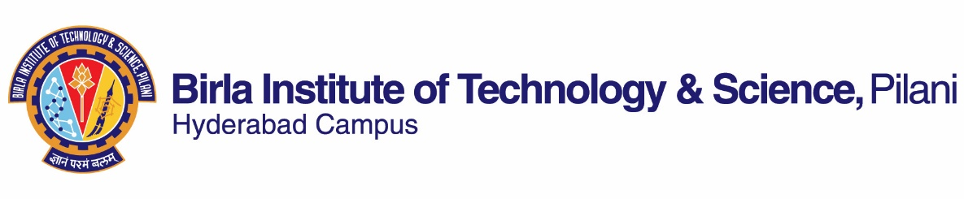
FIRST SEMESTER 2020-2021
Course Handout Part II

Date: 17-08-2020

In addition to part-I (General Handout for all courses appended to the time table) this portion gives further specific details regarding the course.
Course No. : INSTR F343
Course Title : Industrial Instrumentation & Control
Instructor-in-charge : Balasubramanian M
Instructor : Balasubramanian M

- Scope and Objective of the course
This course offers study of various aspects of automatic control for industrial processes, including some recent developments in the field of process control.

- Course Description:
Introduction to process control; Elements of process loop; Controller principle; Hydraulic, pneumatic, electronic controllers; Controller tuning; Final control elements; Control loop characteristics; Complex control systems; Intelligent controllers; Programmable logic controllers; Distributed control systems; Digital control principles;

- Text Book:
Surekha Bhanot, Process Control: Principles and Applications, Oxford University press, Fourth Impression 2010

4. Reference Book:
R1 C.D. Johnson, Process Control Instrumentation Technology, Prentice Hall of India, New Delhi, 1993
R2 Liptak B.G., Process Control: Instrument Engineer’s handbook, Butterworth Heinemann
R3 Krishan Kant, Computer Based Industrial Control, Prentice Hall of India, New Delhi, 1997
R4 Stephanopoulos George, Chemical Process Control, Prentice Hall of India
R5 Ogata K., Modern Control Engineering, Pearson Education Asia

- Course plan

Lecture  No. | Learning Objective | Topics to be covered | Chapter in the Text Book
1,2 | To appreciate the needs, objectives of process control | Basic Control loop, variables, requirements, aims, parameters, dynamics of the process | T-CH1 R4(1.9)
3 | To understand the dynamics of processes | Terms, concepts used in process dynamics | T-CH2
4 | To understand/review the concepts of Transfer function | Transfer functions, block diagram and signal flow representation | R5-CH4
5 | To understand need and concept of mathematical modeling | Model of lumped and distributed parameter systems | T-CH2, R3 –CH11, R5-CH2,3&4
6,7 | To understand steady state and transient analysis | Transient and steady state analysis of first order, second order and higher order systems and numerical to highlight concepts | R5-CH5
8 | To understand different controller modes | On-off, on-off with neutral zone | T-CH3 , R4(9), R3 – CH1
9,10 | To understand different controller modes | Proportional, Integral, derivative, PI, PD, PID | T-CH3, R4(9), R3 – CH1
11,12 | To learn dynamic behavior of feedback controlled systems | Effect on dynamic behavior of process with different controller modes in closed loop with | T-CH4, R4(14)
13 | To learn about controller tuning | Ziegler, Cohen-Coon, Integral performance | T-CH4, R4
14 | To learn about DDC loop | Sampling and reconstruction, DDC structure, position & velocity algorithm | T-CH5
15 | To realize controller modes in pneumatic controllers | Controller modes in Pneumatic controllers | T-CH6, R5 (4.3)
16 | To realize controller modes in hydraulic controllers | Controller modes in Hydraulic controllers | T-CH6, R5 (4.4)
17 | To realize controller modes in electronic controllers | Controller modes in Electronic controllers | T- CH7, R1(10.3)
18,19 | To learn the evolution, hardware of Programmable Logic Controllers | PLC vs relay Logic, PLC vs PCs, hardware components | T-CH13, R3(5),R2
20,21 | To learn ladder diagram programming | Ladder diagram, selection of PLCs | T-CH13, R3(5),R2
22 | To learn application of AI techniques in process control | Role of AI | T-CH14, R3(13),R2
23,24 | To learn ES structure & Application | ES structure, Design & Applications | T-CH15, R3(13)
25,26 | To ANN concepts | Neural networks – structure, applications | T-CH16, R3(18), R2
27,28 | Learning algorithms | BPA, learning | T-CH16, R3, R2
29 | Case studies | Examples, Matlab simulation | T-CH16
30,31 | To learn concept & applications of FLC | Fuzzy controllers | T-CH17, R3(13),R2
32 | To learn about different final control elements | Functions of control valves, Types of control valves, actuators | T-CH8, R3 –CH4
33 | To understand P&I diagrams | Draw P&I diagrams | T-CH9
34,35 | To understand complex control schemes | Cascade control, Ratio control, | T-CH10, R4(20, 21)
36 | To understand complex control schemes | Feedforward, Adaptive control, Inferential, Model reference adaptive control, Self tuning regulator | T-CH10, R4 (21)
37-38 | To understand complex control schemes | Override, Auctioneering, Split Range | T1-CH11, R4(22)
39-40 | To understand interaction and decoupling of control loops | Design of cross controllers and selection of loops using RGA | T-CH12, R4(24)
41-42 | To understand distributed digital control systems | History, functional requirements, system architecture, configuration | T-CH18, R3(6),R2

- Evaluation Scheme
Components | Duration | Weightage | Marks | Date & Time | Nature of Component
Test-1 | 30 min | 10% | 10 | September 10 –September 20 (During scheduled class hour) | Open Book
Test-2 | 30 min | 15% | 15 | October 09 –October 20 (During scheduled class hour) | Open Book
Test-3 | 30 min | 15% | 15 | November 10 – November 20 (During scheduled class hour) | Open Book
Term Paper / Assignments | - | 30% | 30 | Take Home | Open Book
Comprehensive | 120 min | 30% | 30 | TBA | Open Book
Total |  | 100% | 100

- Chamber Consultation Hour : To be announced in the class.
- Course Notices: Notices will be displayed in CMS.
- Make-up Examination: Make-up will be given on extremely genuine grounds only for those receiving prior approval.
- Academic Honesty and Integrity Policy: Academic honesty and integrity are to be maintained by all the students throughout the semester and no type of academic dishonesty is acceptable.

Instructor-in-charge
INSTR F343

